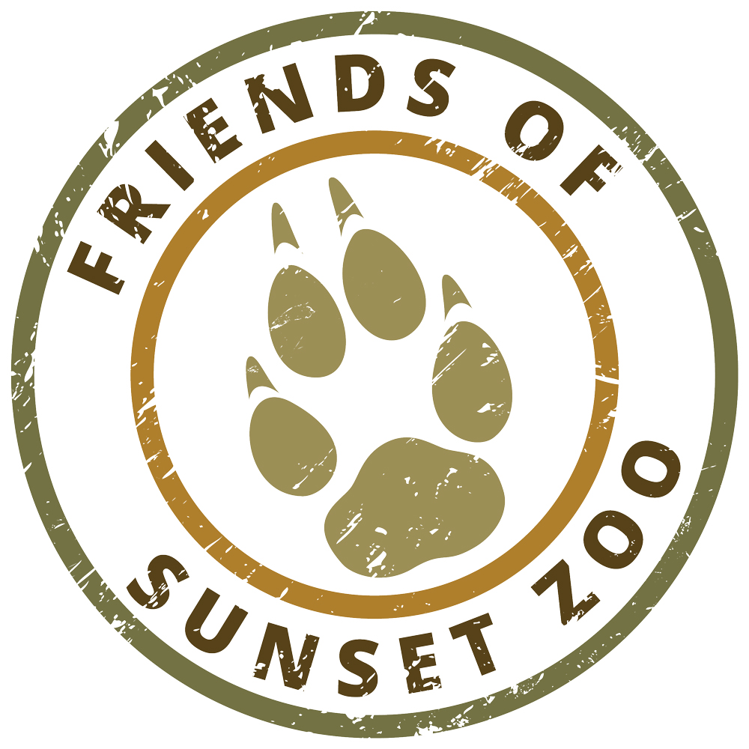
FOSZ CONSERVATION SCHOLAR PROGRAM –IMPACT REPORT
For an electronic copy of this report visit: www.SunsetZoo.com/Conservation
Questions? Email: fosz@cityofmhk.com • Phone: 785.587.2737

Congratulations on being named a Friends of Sunset Zoo Conservation Scholar! We’re excited for you to join us on our mission to “inspire conservation of the natural world.” In addition to your scholarship award, we would like to share your exciting conservation efforts with the community. This completed report must be received by the Friends of Sunset Zoo Board of Directors within one month of completing your field conservation work.
This information will be posted on Sunset Zoo’s Behind the Science Website: www.sciencemhk.com. Because this will be shared online, please complete your report with a public audience in mind. This is not for a scientific audience. When completing each section, please make it personal. As you can see from this resource, a personal touch will set your report apart from the rest: https://bobwp.com/ultimate-guide-writing-online-bio/. For guidance or questions about this report, feel free to contact us at behindthescience@cityofmhk.com.
    - QUESTIONAIRE
Full Legal Name

LAST FIRST M.I.

- Briefly describe the impact of your field conservation work (Limit 350 characters with spaces):

- Describe your completed field conservation project including any changes from your original application. (Limit 1,750 characters with spaces or less)

- Describe two to three things you learned as a result of this project. (Limit 1,750 characters with spaces or less)

- How did this project impact your professional goals? (Limit 1,750 characters with spaces or less)

- Do you have a blog, online video channel (YouTube, Vimeo, etc.), or social media account related to your research that we can help promote? Include links, handles here.

    - PHOTO DOCUMENTARY
In addition to the completed questionnaire, please submit at least five high-resolution (300 dpi or higher) digital photos of the research project (highlighting the project in progress & completed, as well as at least one with you in the photo).

    - REPORT PRESENTATION (AWARDEES LOCATED WITHIN 90 MILES OF MANHATTAN, KS ONLY)
Please contact the FOSZ Conservation Team in order to schedule a 45-minute presentation of your report. Email fosz@cityofmhk.com or call 785.587.2737.

Please consider how you will invest your knowledge and conservation field research in others as a mentor, teacher, volunteer, etc.

