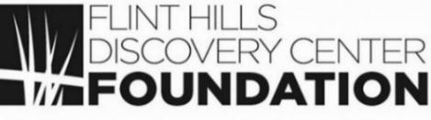
V I S T A S
___________________________________________________________________________________________
From the desk of Lesley White, Foundation Director
June 2021 / Volume 5, Issue 5

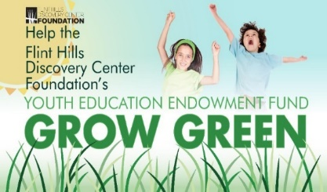
Thank You!
Grow Green. GMCF Match Day.

Thank you! Thursday, April 22nd the Flint Hills Discovery Center Foundation Education Endowment participated in the 9th Annual Grow Green Match Day! More than $14,500 was gifted from 56 donors. The Grow Green Match added another $5,700 to total $20,200.

We are grateful to each of our donors and to the Green Match challenge grant provider. These gifts make the Discovery Center’s education programs possible. Join us in thanking these great supporters!

------------------------- FHDCF Match Donor Marquee ------------------------

Mitch & Susan Adams
Donna Alexander
Anonymous
Suzan Barnes
Christine Benne
Dan & Beth Bird
Stephen Bridenstine
Sylvia Campbell
Mike & Julia Clark
BHS Construction
Jeff and Kelley Davidson
Thyra Davis
Tom Eddy
Orazem & Scalora Engineering
Ronald & Renee Fehr
ESB Financial
Enell Foerster
Gloria Freeland
Jackie Frintrup
Steven & Cheri Graham
Gary & Carolyn Haden
Robert & Mary Haines
Dennis Hemmendinger
Craig Neill & Katharine Hensler
Bill & Faye Kennedy
Carol Keltner
Ann Kosch
Dave Lewis
Jack & Lindy Lindquist
Sue Maes
V Marie Martin
John & Karen McCulloh
Jonathan Mertz
Bob & Jane Mullen
Carlin & Stephanie Murphy
Tom & Kathy Neill
Kent & Lana Oleen
Moxley Ranch
Jim & Sherry Reed
Charles & Sue Rice
William Richter
Brad & Lauren Ritterbush
Jim Sharp
Bradley & Susie Shaw
Frank & Mary Siegle
Bruce & Leslie Snead
David Sachs & Rebecca Stark
Frank & Sarah Tortella
Marty Vanier
Harry & Sherry Watts
John & Marlyn Walters
Ruth Wells
Karin Westman
David Whitney
Kent Glasscock & Janna Williams
Fred & Lorraine Willich

Hands on Harley Davidson™- May 15th – September 12^{th.}
Hit the road with Hands-On Harley Davidson ™ the new traveling exhibit at the Flint Hills Discovery Center! Step into a kid sized Harley-Davidson® dealership with two customizable Road-King®- inspired motorcycles. Go for a virtual ride in our simulator. Learn how engines work, the “rules of the road,” and bike maintenance. Enter the “Engineering Lab” to design and test your own freestyle track with tracks, ramps, and loops.

See real vintage motorcycles including a commemorative Evel Knievel Harley, 1913 Board Track motorcycle, and XR-750 Harley. Visit https://www.flinthillsdiscovery.org/657/Coming-Soon-Hands-On-Harley-Davidson to learn more about this exciting new exhibit!

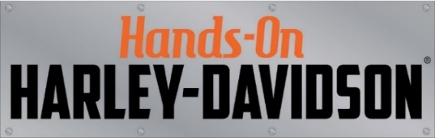
At Hands- On Harley Davidson,
you are invited to Dream It!... Build It! … Ride It!

Kansas Tax Credits Available for KIDSCAPE!

The Foundation is funding KIDSCAPE! – an exciting renovation of the second-floor perimeter under the dome – with the goal of opening on the 10th anniversary of the DC on April 14, 2022! We have Kansas Community Service 50/50 Tax credits available for this – for example, a person donating $10,000 would receive a check for $5,000 from the State of Kansas and could also claim a $5,000 charitable donation on their taxes. The first phase of design services was awarded by the City Commission on June 15th with the second phase of construction of this $1.3 million dollar project scheduled in early fall. Please help us achieve this unique milestone in the history of the Discovery Center!
For more information email Lesley White at fhdcfoundation1@gmail.com or call 785-748-1275.

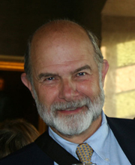
John Reese, Foundation Board of Directors

John Reese retired from Kansas State University after 34 years of service in 2016. John taught Economic Entomology and Plant Resistance to Insects. He specialized in aphid salivary enzymes in insect- plant interactions, plant resistance to aphids and plant tolerance to aphid feeding damage. John is serving his second three-year term at the Foundation.

The Flint Hills Discovery Center Foundation
315 S. 3rd Street, Manhattan, KS 66502
(785) 748-1275 / fhdcfoundation1@gmail.com
VISTAS is provided to advance the cause of philanthropy in support of the Flint Hills Discovery Center.

