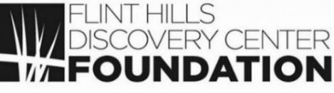
V I S T A S
___________________________________________________________________________________________
From the desk of Lesley White, Foundation Director
August 2021 / Volume 5, Issue 7

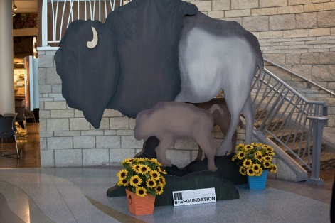
Bison, Beef & Bourbon – 2nd Annual

Please join us October 23rd for our 2nd Annual signature event, Bison, Beef and Bourbon. The event will be held from 6:30 pm to 9 pm at the Flint Hills Discovery Center. Enjoy a night of heavy appetizers featuring bison and beef cuisine, complimentary drinks including Horse Solider Bourbon, live entertainment, a silent and live auction, and great conversation!

Proceeds from the night will help complete the funding for KIDSCAPE, the 2nd floor renovation project to be completed in 2022. This interactive children’s experience will use the sciences and history to teach children about the Flint Hills!

For more information about Bison, Beef & Bourbon, please contact Foundation Director, Lesley White at fhdcfoundation1@gmail.com, call 785 748 1275, or go to the Flint Hills Discovery Center Foundation Facebook page for event information and ticket information. Tickets will go on sell September 1st.

Upcoming Fall Events!

School is back in session, which means fall events are beginning at the Discovery Center:
- StoryWalk Downtown- September 3rd- September 29th

- Adventure Camps- K-2 camps to be held until Christmas. Grades 3-6 will be held after Christmas.

- Preschoolers- FREE programs offered on select Tuesday mornings

- NEW! Nature Together- program for babies/ toddlers (0-3)

- NEW! Nature Explorers Jr- program for youth ages 5-15

- NEW! Prairie Garden Walks- for seniors ages 50+

- New- Outdoor Classroom Program Scholarships- for grades K-5 to visit the FHDC

- Ask an Expert- first one is scheduled for September 9th

- New! Low Sensory Saturdays- October 2 and November 6th the FHDC will open one hour early to accommodate individuals with sensory processing disorders

- Hands on Harley Davidson- Last day is September 12th

- Dinosaur Discoveries: Ancient Fossils, New Ideas- opens September 25th

More information on all these programs can be found at www.flinthillsdiscovery.org

Tax Credits Available to Donors

Have you ever used Kansas Community Service Tax Credits? If you make a donation of $1,000 or more to the Foundation before December of this year, the State of Kansas will return 50 percent of your gift to you when you file your 2021 tax return in the Spring of 2022. You use tax form K-60 to claim the credits. For Example, if you donate $5,000, the State of Kansas will return $2,500 to you and you can take a charitable deduction on the remaining $2,500.

These credits were awarded to The Foundation to support the Discovery Center’s new KIDSCAPE Experience to be built on the second floor of the Discovery Center.

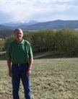
Ken Wold, FHDC Board Member

Ken recently retired after 32 years with the YMCA. During his last 23 years he served as CEO of Camp Wood YMCA near Elmdale in Chase County, KS. During his time, Camp Wood updated and added facilities and increased enrollment to about 2,000 summer campers, annually and more than 5,000 annual participants.
Living and breathing tallgrass prairie for 23 years, Ken sees great value in the work and opportunities provided by the Flint Hills Discovery Center. Not everyone can spend a week exploring the Flint Hills. The Discovery Center is the perfect introduction for many to this unique place. It educates children and adults on the importance of the prairie and the grasses found in these hills. It encourages and inspires visitors to experience the grassland and its communities up close,” says Wold.
“The key to success for the Center is to remember that we are not a cookie cutter science center, but a place that concentrates on the value of the Flint Hills and Tallgrass Prairie.”

----------------------------------------------------------------------------------------------------------------------------------------------------------------------------------------------------------

The Flint Hills Discovery Center Foundation
315 S. 3rd Street, Manhattan, KS 66502
(785) 748-1275 / fhdcfoundation1@gmail.com
VISTAS is provided to advance the cause of philanthropy in support of the Flint Hills Discovery Center.

